Dear Parents and Guardians:

Anti-Bullying Day or Pink Shirt Day is a tradition in Canadian schools. It started in Nova Scotia when a Grade 9 boy was being harassed for wearing a pink shirt. In response, classmates of the boy went and bought 50 pink shirts and the next day at school handed them out to their peers. When the bullied boy arrived at school the next day he was surrounded in pink solidarity. Together, united, they took a stand against bullying. Officially Pink Shirt Day is Wednesday, February 23rd but we are not in school that week. As such, Coyote Student Council is making Wednesday, March 2nd Wheatland Crossing’s Pink Shirt Day.

As such we are offering the option of purchasing a custom-made Pink Shirt for the occasion. Each shirt is $20 and you have the choice between two design styles.

Sizes Available are:
Youth: YXS (2-4) YS (6-8) YM (10-12) YL (14-16) YXL (18-20)
Adult Sizes: Small to 4XL

Design Options:
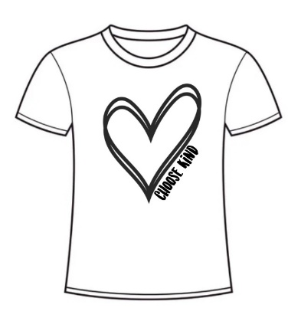

If you would like to order please fill out the order form below, attach payment, and please return to the school by Wednesday, February 16th. You can also pay online with an e-transfer to wheatlandcrossing@ghsd75.ca and in the subject line please write ‘students name- pink shirt’ so our secretaries know where to direct the funds to and who the payment is for. Shirts will be delivered to students Monday, February 28th to wear for Wednesday, March 2nd! .

Thank you!
Coyote Council

---------------------------------------------------------------------------------------------------------------------------------------

Name of Student: ______________________________________________
Grade/Class: _______________ Design (circle one) : Heart or Bee
Size: ________________ Payment (circle one): Cash Cheque E-Transfer

